**VERSIONE BASE NO FINE TUNING**

# Hyperparameters before fine tuning, these will be displayed on wandb and then there will be fine tuning again through wnadb

setting = {

"window_size": 64, # var

"test_split_size": 0.10, # var

"dimTrValDataSet": 0.90, # var

"input_size": 61, # fix

"num_lstm_layers": 1, # var

"lstm_size": 200, # fix

"dropout": 0.3, # var

"nStepsAhead": 24, # var

"l1_factor": 1e-5, # var

"weight_decay": 0.001, # var

"trW": 4, # var

"vlWl": 2, # var

"batch_size": 64, # var in [16, 32, 64, 128, 256]

"num_epochs": 500, # var

"learning_rate": 3e-4, # Adam # var 0.01 se uso RMSprop

"optimizer": "Adam", # "RMSprop" , # var https://pytorch.org/docs/stable/generated/torch.optim.RMSprop.html#torch.optim.RMSprop

"momentum": 0.8, # var

"scheduler": "ReduceLROnPlateau", # "CosineAnnealingWarmRestarts", "OneCycleLR" # var

"scheduler_factor": 0.5, # var

"scheduler_patience": 3, # var

"scheduler_min_lr": 1e-6,

"l1_lambda":0.01,

"eps": 1e-8,

"alpha": 0.99,

"patience": 40,

"min_delta": 0.005,

"device": "cuda"

1. TR-VAL window normale
   * **No FineTuning**
2. Esecuzione con database standard predizione HLC3
3. Esecuzione con database LC2

3. Esecuzione con database OHLC4

* **FineTuning semplice**
* **FineTuning con F-Loss personalizzata**
* PCA

2. TR-VAL k-fold validation

* + **No FineTuning**

1. Esecuzione con database standard predizione HLC3
2. Esecuzione con database LC2

3. Esecuzione con database OHLC4

* FineTuning semplice
* FineTuning con F-Loss personalizzata
* PCA

18 feb 2024

* Risultati rete CNNLSTM NO fine tuning, NO PCA, pred HLC3 → 24 ahead (versione base), NO kFold
* link output [predictionsResult](https://drive.google.com/drive/folders/1pivNtenOedDFLKZrhHvIQtxx5gQCrOH3?usp=drive_link)
* link code [code](https://colab.research.google.com/drive/1vvicdHhWrig50syVnqts)
* link wandb [wandb](https://wandb.ai/stefanobutera98/KA-TY-AI-trValW-CNNLSTM/runs/87zrrf26?workspace=user-stefanobutera98)
* model PTH [modelPTH](https://drive.google.com/file/d/1-0-SYF9ohklXmE1UuPJv3uQnv9Qjni-G/view?usp=sharing)

Risultati

TRset:

| MSE | RMSE | R2 |
| --- | --- | --- |
| 0.000277 | 0.016635 | 0.995625 |

VLwin:

| MSE | RMSE | R2 |
| --- | --- | --- |
| 0.000276 | 0.016619 | 0.995642 |

TSwin:

| MSE | RMSE | R2 |
| --- | --- | --- |
| 0.000123 | 0.011071 | 0.986957 |

Scatter plot on TS result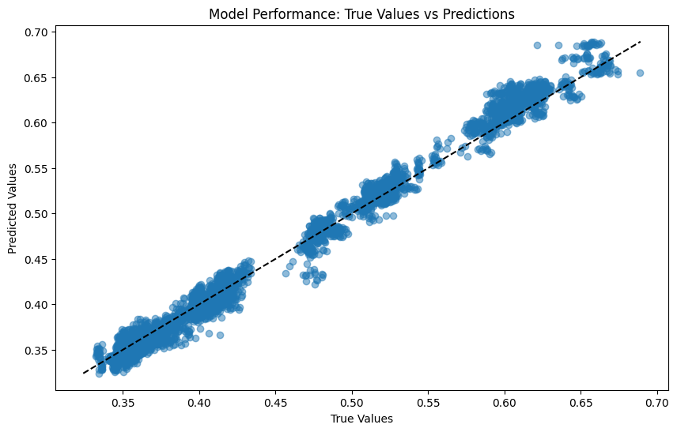

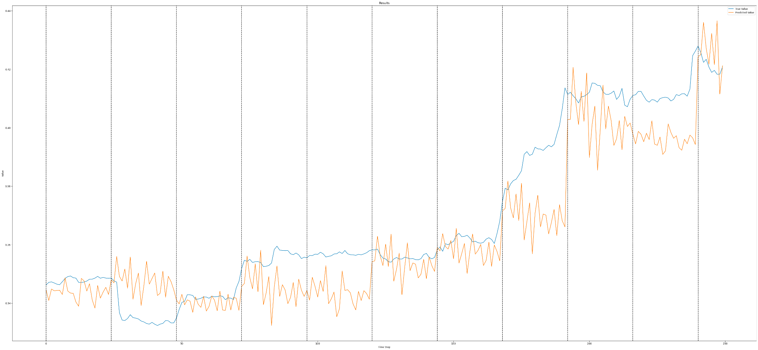

19 feb 2024

* Risultati rete CNNLSTMohlc4 NO fine tuning, NO PCA, pred HLC3 → 24 ahead (versione base), NO kFold
* link output [predictionsResult](https://drive.google.com/file/d/1jjE4gRj_z5wUIQtvZXdlaW8AQhReyhD9/view?usp=drive_link)
* link code [code](https://colab.research.google.com/drive/1jjE4gRj_z5wUIQtvZXdlaW8AQhReyhD9#scrollTo=ns4a-wsOxhZt)
* link wandb [wandb](https://wandb.ai/stefanobutera98/KATY_AI_OHLC4_CNNLSTM/runs/rq8fk4l7?workspace=user-stefanobutera98)
* model PTH [modelPTH](https://drive.google.com/file/d/1-6ODd619VHBCYy4l9ZYPjW6Q4LDhKM-5/view?usp=drive_link)

Risultati

TRset:

| MSE | RMSE | R2 |
| --- | --- | --- |
| 0.0.000296 | 0.0.01719 | 0.995332 |

VLwin:

| MSE | RMSE | R2 |
| --- | --- | --- |
| 0.0.000295 | 0.017174 | 0.995351 |

TSwin:

| MSE | RMSE | R2 |
| --- | --- | --- |
| 0.000169 | 0.012992 | 0.982055 |

Scatter plot on TS result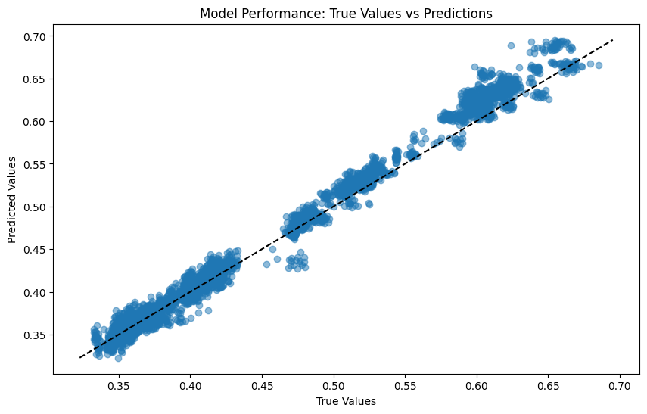

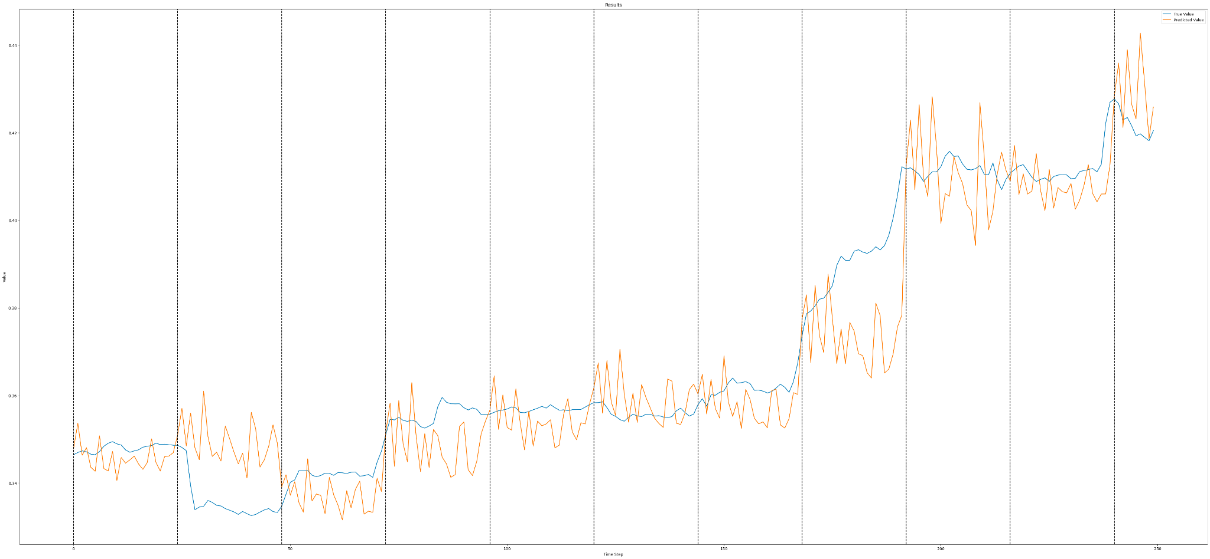

19 feb 2024

* Risultati rete CNNLSTMlc2 NO fine tuning, NO PCA, pred HLC3 → 24 ahead (versione base), NO kFold
* link output [predictionsResult](https://drive.google.com/drive/folders/1wvAHBFmGMcEtp6sXoT567dgof4Tkeh9Y?usp=drive_link)
* link code [code](https://colab.research.google.com/drive/1OVbg_9-ulwEHFTWVZKdzR3xsPZtMvtHn#scrollTo=XLv5tb1zSJBu)
* link wandb [wandb](https://wandb.ai/stefanobutera98/KATY_AI_OHLC4_CNNLSTM/runs/trqhdrja)
* model PTH [modelPTH](https://drive.google.com/file/d/1-3NyWyuh-jL_gql0KO66tf_Rjotc2oT2/view?usp=drive_link)

Risultati

_______Epoch 499/500:_______

Mean Train Loss: 0.0004976523321909974

Val Loss : 0.0003284538197420508

TRset:

| MSE | RMSE | R2 |
| --- | --- | --- |
| 0.000329 | 0.018138 | 0.994807 |

VLwin:

| MSE | RMSE | R2 |
| --- | --- | --- |
| 0.000328 | 0.018123 | 0.994827 |

TSwin:

| MSE | RMSE | R2 |
| --- | --- | --- |
| 0.000211 | 0.014541 | 0.97755 |

